**Press Release**

**The Standard Steam Locomotive Company (SSLC)**

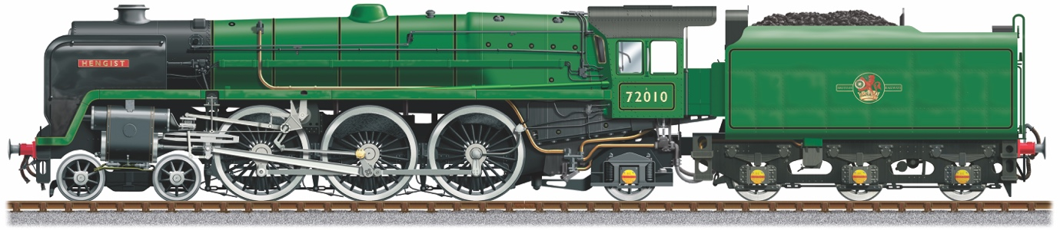

**----------------------------------------------------------------------------------------------------------------**

**William Cook Cast Products to cast six new driving wheels for Locomotive – 72010 Hengist**

The Standard Steam Locomotive Company are Building a new ‘Clan’ Class 6 Steam Locomotive, number 72010 ‘Hengist’

William Cook Cast Products (WCCP) will make all six driving wheels, based around two patterns; one for the Centre Driving Wheel and one for the Leading and Trailing Wheels. The patterns will be made using traditional methods, assisted by laser scanning of the wheels on Hengist’s ‘big sister’ Britannia pacific 70013 Oliver Cromwell, based at the Great Central Railway’s Loughborough depot. The scan will define any missing details for the finished patterns.

From the patterns, the two centre driving wheels and four leading and trailing wheels will be cast. All six cast wheels will then be proof (semi-finished) machined ready for finish machining to suit the axles and tyres. All this work will take between six and twelve months to complete and will be worth over £100,000 to the project.

**William Cook - Heritage Rail**

William Cook is a major supporter of steam locomotive new-build and restoration projects in the UK and Europe.

Sir Andrew Cook CBE said of the project….” Britain is now entering the second and most hazardous stage of the heritage rail movement which began some 60 years ago. Preserved locomotives are requiring hugely expensive repairs, including new boilers and the generation of men whose knowledge and enthusiasm preserved them in the first place is dwindling as death takes its inevitable toll. In this context, new build is ever more important if the working steam locomotive is not to become a thing of the past. As both a life-long rail enthusiast and experienced manufacturer of the many kinds of cast parts a steam engine requires, I consider it my duty to our industrial heritage to do what I can to assist. The ‘Clan’ class was a pretty engine, but no example escaped the scrap man’s torch. ‘Hengist’ is a state-of-the art engineering project based in the heart of Sheffield and could even be the last Pacific locomotive built in the UK. Such iconic locomotives are a major part of our history, without which future generations would never experience the sight, sound and even smell of a working steam locomotive.”

Andy England, MD of CTL Seal in Sheffield, which is the home of the Locomotive, says “This is a fantastic development for the Locomotive and the project is building a real head of steam now. You can really see the engine taking shape and it’s an exciting challenge for us as we are re-creating the engine using the original 1950s design but employing 21st century engineering techniques to make it greener, cleaner and more efficient.”

Come and see the Locomotive at our Open Day on Saturday 13th April – 10am-4pm at CTL Seal, Butterthwaite Lane, Ecclesfield, Sheffield S35 9WA

End

**----------------------------------------------------------------------------------------------------------**

**SSLC Background**

**Engineering the Future of Steam in Sheffield**

**Building the lost ‘Clan’ Class 6 Steam Locomotive, called the 72010 Hengist**

Originally built in 1952, only 10 of this Iconic British Rail (BR) Locomotive were ever built out of a planned 118. This was due to a steel shortage and the modernisation of the rail network with the introduction of Diesel locomotives.

None of the original locomotives exist now. SSLC are building what would have been the 11th ‘Clan’ Class 6 Locomotive and the 1000th brand new BR locomotive.

Steam Locomotives are part of our national heritage. Everyone likes to see and hear a steam train racing though the countryside. It’s captivating for everyone, albeit for different reasons. A distant memory, a reminder of a past age or simply just an awesome thing to see.

SSLC are preserving the history and heritage for future generations to enjoy.

**Made in Sheffield**

Leading precision engineering company, Sheffield based CTL Seal, was chosen to build this iconic ‘lost’ locomotive, using a combination of volunteer expert engineers and CTL Seals experienced design and manufacturing team – known as the Sheffield Steam Team!

This project requires a combination of expert craftsmanship combined with 21st century design and technology, to not only re-create the engine in all its aesthetic glory (built to the original design spec), but significantly increase the overall performance and efficiency of the locomotive.

**Re-engineering a more sustainable and future-proof Locomotive**

SSLC are building a much 'greener & cleaner' locomotive and are also preparing the locomotive for the future, with the long-term development of sustainable steam, The new engine design can be more easily be adapted to take advantage of alternative manufactured fuels that are being developed, using biomass as a key component.

**Greener & Cleaner – Better use of fuel**

To make Hengist ‘greener’, two key changes are going to be made. Firstly, increase

boiler pressure by 25 psi from 225 psi to 250 psi, which extracts more energy from

the fuel and secondly, design a 21st century exhaust system which improves

combustion and reduces backpressure on the cylinders. Computer simulations

suggest that these two improvements help Hengist reduce harmful greenhouse gas

emissions, by up to 10.5%.

**More Powerful** - **Essential for steam operation on today's railway**

The higher boiler pressure and the improved exhaust system also mean that Hengist is 22% more powerful. The benefit is that it can pull more coaches or run faster uphill, giving greater operational flexibility for running on the mainline.

**More Efficient - More effective use of steam**

When new, the original Clans had one of the lowest fuel consumptions of any British

Standard Steam Locomotive. Hengist is expected to improve on this. As well as the

improved exhaust system and higher boiler pressure other improvements are going

to be made to the pistons and valves to reduce steam leakage and reduce wear,

through improved materials and lubrication.

**Another high-profile engineering project Sheffield can be proud of**

SSLC is a registered charity and need to raise £4M to re-create this iconic locomotive in all its glory. Completion date for the Locomotive is 2029 and after that you will see it running on heritage and eventually mainline rail networks.

**---------------------------------------------------------------------------------------------------------**

Steven Cooper, Hengist Fundraiser & Marketing. Contact 07879 602995

For more information, please visit

[www.72010-hengist.co.uk](http://www.72010-hengist.co.uk)

To give a one-off donation, please go to our Go Fund Me Page

[www.gofundme.com/hengist](http://www.gofundme.com/hengist)

The Standard Steam Locomotive Company Ltd

C/O CTL Seal, Butterthwaite Lane, Ecclesfield, Sheffield S35 9WA

Charity No.1062 320 Co.Reg. 3192 444