**Press Release**

**The Standard Steam Locomotive Company (SSLC)**

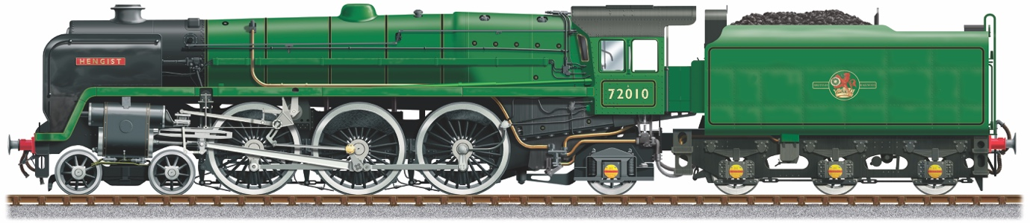

**----------------------------------------------------------------------------------------------------------------**

**Worshipful Company of Ironmongers to fund two cast iron cylinder rear covers for HENGIST**

The Standard Steam Locomotive Company are recreating a new ‘Clan’ Class 6 Steam Locomotive, number 72010 HENGIST

The cylinders provide the driving force for the locomotive and the £6,300 grant will be used to manufacture two rear cylinder end covers.

A housing, cast in the cover, contains a packing system to seal the piston rod as the cylinder contains high pressure steam. SSLC will be making a modification to the original British Railways design in that an extension will be part of new casting and will provide support for the front of the slidebars. The aim is to improve on the excessive piston ring wear of the original design.

James Baldwin, SSLC President, says “This is a fantastic development for the Locomotive and the project is building a real head of steam now. You can really see the engine taking shape and it’s an exciting challenge for us as we are re-creating the engine using the original 1950s design but employing 21st century engineering techniques to make it greener, cleaner and more efficient.”

Charlie Knaggs, Clerk of the Worshipful Company of Ironmongers said: “We are delighted to support the SSLC’s project to build the iconic 72010 Steam Locomotive. With our centuries-old roots in the iron trade, it is right and fitting that we contribute these new and improved cast iron components to the project.”

End.

**Worshipful Company of Ironmongers**

One of the Great XII Livery Companies of the City of London, our links to the Iron trade reach back 700 years. An unassuming, inclusive and welcoming Company, our charitable endeavours unite our past, present and future. We administer six charities, focussed on the education of the young, the care of the elderly, metals and materials science.

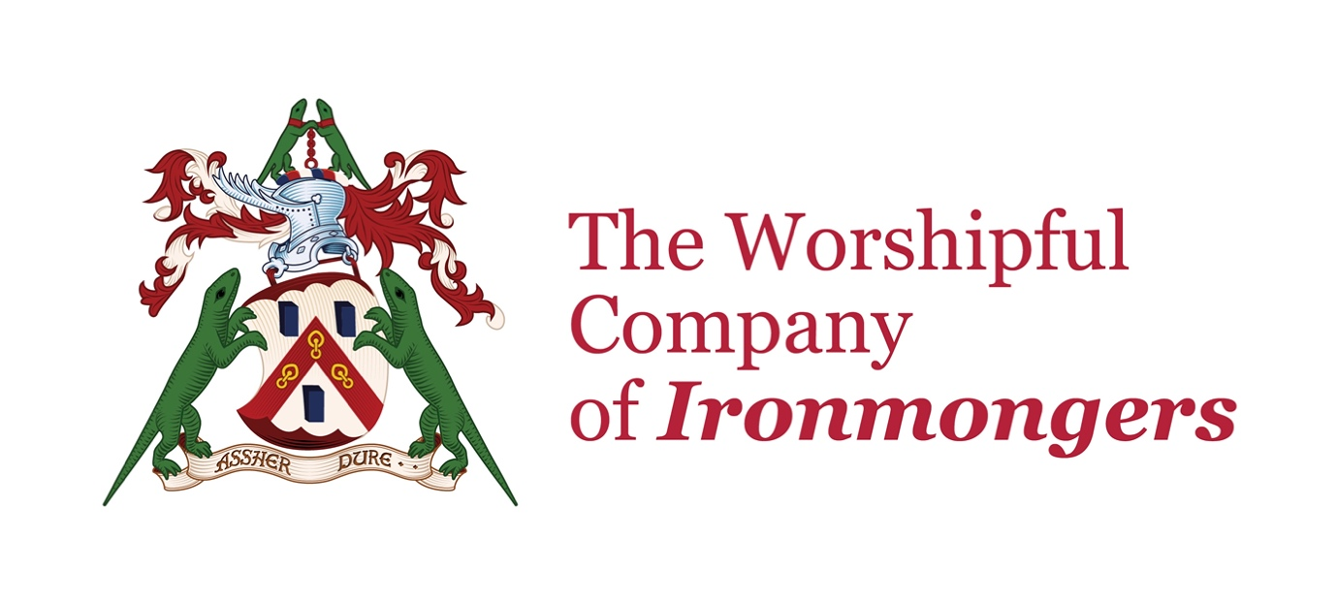

**SSLC Background**

**Engineering the Future of Steam in Sheffield**

**Building the lost ‘Clan’ Class 6 Steam Locomotive, called the 72010 Hengist**

Originally built in 1952, only 10 of this Iconic British Rail (BR) Locomotive were ever built out of a planned 118. This was due to a steel shortage and the modernisation of the rail network with the introduction of Diesel locomotives.

None of the original locomotives exist now. SSLC are building what would have been the 11th ‘Clan’ Class 6 Locomotive and the 1000th brand new BR locomotive.

Steam Locomotives are part of our national heritage. Everyone likes to see and hear a steam train racing though the countryside. It’s captivating for everyone, albeit for different reasons. A distant memory, a reminder of a past age or simply just an awesome thing to see.

SSLC are preserving the history and heritage for future generations to enjoy.

**Made in Sheffield**

Leading precision engineering company, Sheffield based CTL Seal, was chosen to build this iconic ‘lost’ locomotive, using a combination of volunteer expert engineers and CTL Seals experienced design and manufacturing team – known as the Sheffield Steam Team!

This project requires a combination of expert craftsmanship combined with 21st century design and technology, to not only re-create the engine in all its aesthetic glory (built to the original design spec), but significantly increase the overall performance and efficiency of the locomotive.

**Re-engineering a more sustainable and future-proof Locomotive**

SSLC are building a much 'greener & cleaner' locomotive and are also preparing the locomotive for the future, with the long-term development of sustainable steam, The new engine design can be more easily be adapted to take advantage of alternative manufactured fuels that are being developed, using biomass as a key component.

**Greener & Cleaner – Better use of fuel**

To make Hengist ‘greener’, two key changes are going to be made. Firstly, increase

boiler pressure by 25 psi from 225 psi to 250 psi, which extracts more energy from

the fuel and secondly, design a 21st century exhaust system which improves

combustion and reduces backpressure on the cylinders. Computer simulations

suggest that these two improvements help Hengist reduce harmful greenhouse gas

emissions, by up to 10.5%.

**More Powerful** - **Essential for steam operation on today's railway**

The higher boiler pressure and the improved exhaust system also mean that Hengist is 22% more powerful. The benefit is that it can pull more coaches or run faster uphill, giving greater operational flexibility for running on the mainline.

**More Efficient - More effective use of steam**

When new, the original Clans had one of the lowest fuel consumptions of any British

Standard Steam Locomotive. Hengist is expected to improve on this. As well as the

improved exhaust system and higher boiler pressure other improvements are going

to be made to the pistons and valves to reduce steam leakage and reduce wear,

through improved materials and lubrication.

**Another high-profile engineering project Sheffield can be proud of**

SSLC is a registered charity and need to raise £4M to re-create this iconic locomotive in all its glory. Completion date for the Locomotive is 2029 and after that you will see it running on heritage and eventually mainline rail networks.

**---------------------------------------------------------------------------------------------------------**

Steven Cooper, Hengist Fundraiser & Marketing. Contact 07879 602995

For more information, please visit

[www.72010-hengist.co.uk](http://www.72010-hengist.co.uk)

To give a one-off donation, please go to our Go Fund Me Page

[www.gofundme.com/hengist](http://www.gofundme.com/hengist)

The Standard Steam Locomotive Company Ltd

C/O CTL Seal, Butterthwaite Lane, Ecclesfield, Sheffield S35 9WA

Charity No.1062 320 Co.Reg. 3192 444